1. **$jobs**: tells what is their in background and foreground.

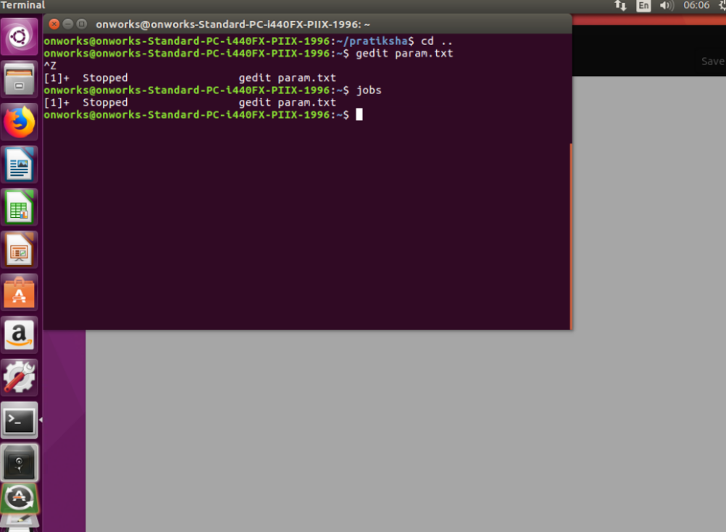

**2.** **$bg %1:** shows the background process while 1 represents the process number.

**3.** **$fg %1**: shows the foreground process.

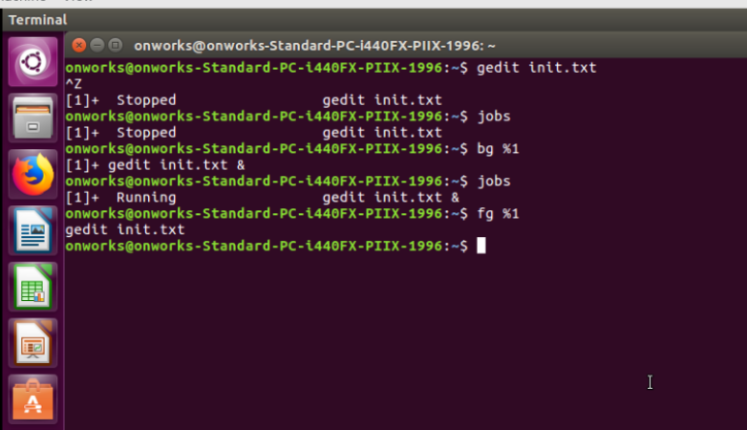

**4. $less:** it is used to read the contents of a text file one page at a time. It has a faster access because if file is large it doesn’t access the complete file bit access it page by page.

**$less –N init.txt:** gives the line number.

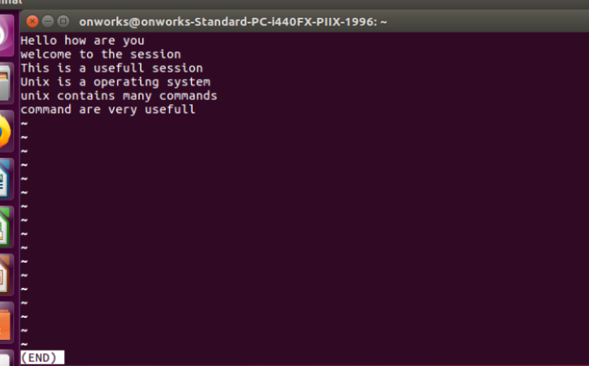

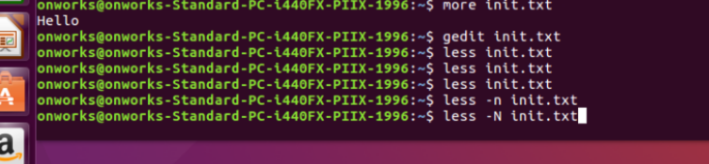

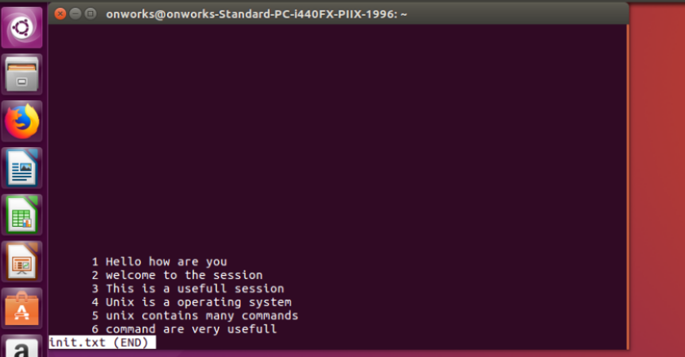

**/Word:** will gives the word which we have searched.

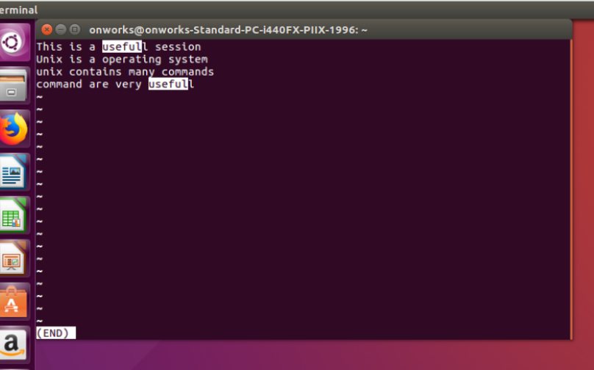

**/ s*:** gives all the occurrences of s.

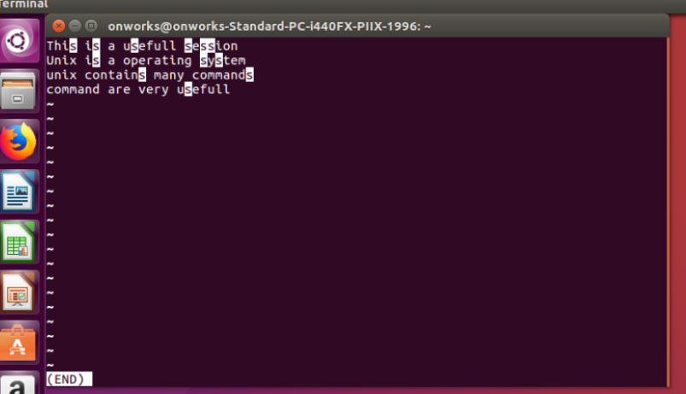

**$ less init.txt init1.txt:** First it will show the first file and after the next. If we want to open the next file :n should be give and for previous file :p.

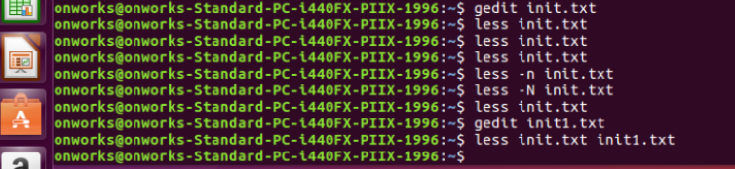

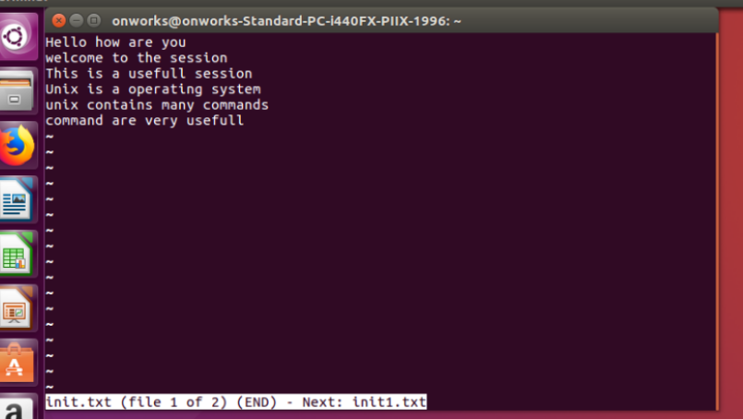

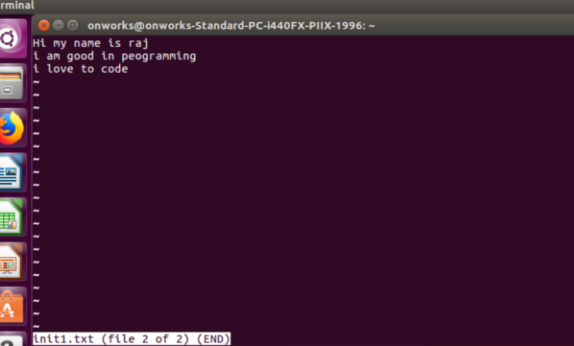

**$less –version:** Gives the information of the license preset in the less.

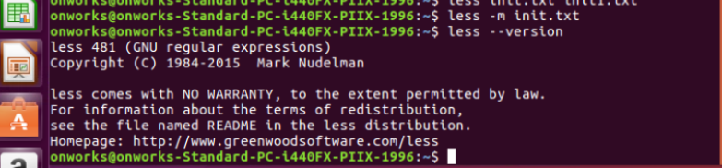

**$less –X init.txt:** This will display the content of the file. We should press ‘q’ for quit

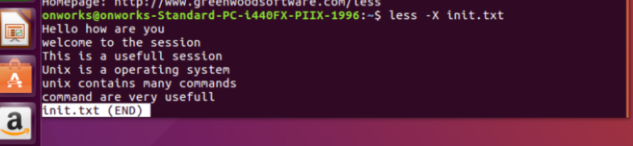

**5. $tail:** This will display a last 10 lines of the file.

**$tail –n 3 name.txt | sort:** this will display last 3 lines and after that sorted in a alphabetical order.

**$tail –n +7 name.txt:** This will prints from the line 7 to the last.

**$cat name.txt | head –6 | tail –3**: This will print the content of the file and display the first 6 line and then from the 6 line it prints the last 3 lines.

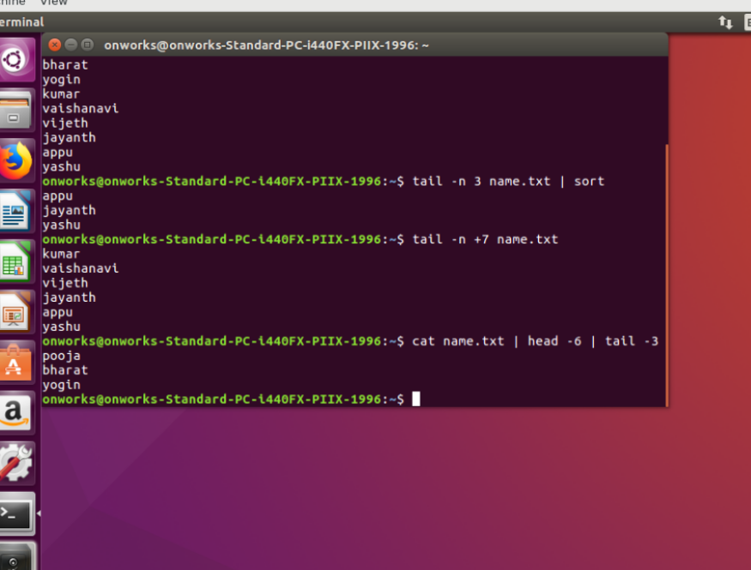

**6. $head:** This will display starting 10 lines.

**$head name.txt demo.txt demo1.txt:** This will display all the files 1 by 1.

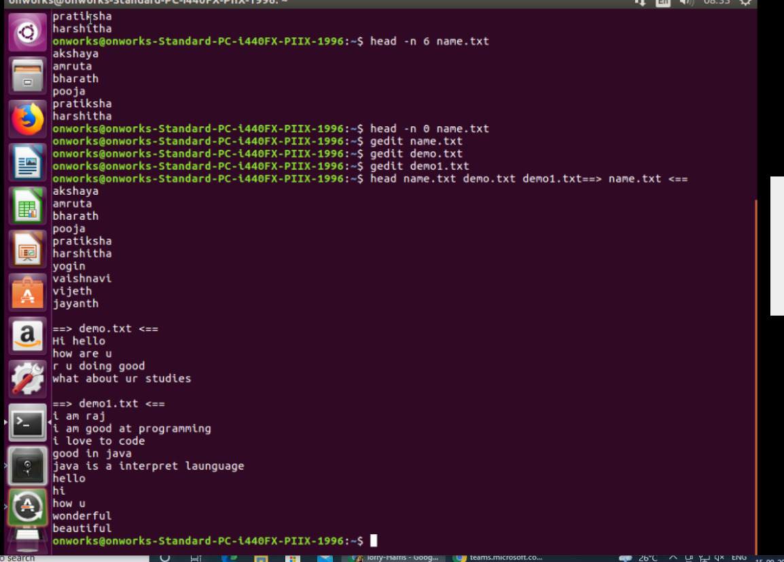

**7. $cat name.txt | tr –d o:** This will delete the ‘o’ in the content present in the file.

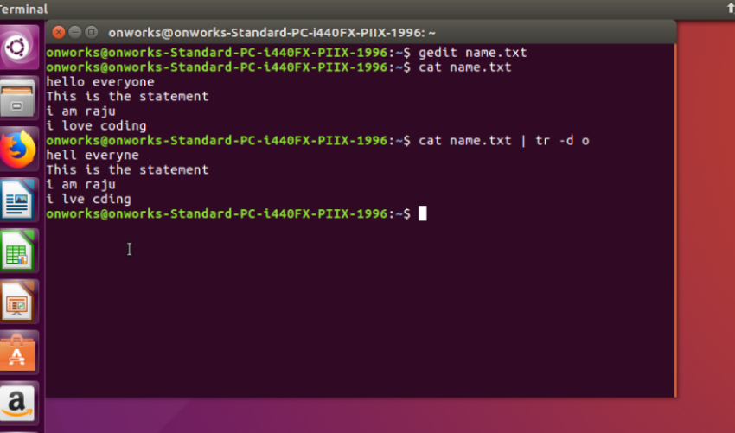

**8. $cat name.txt | tr –d “[a-z]”:** This will delete the alphabets present in the content of the file.

**$cat name.txt | tr –d [:digit:]:** This will delete the numbers present in the content of file,

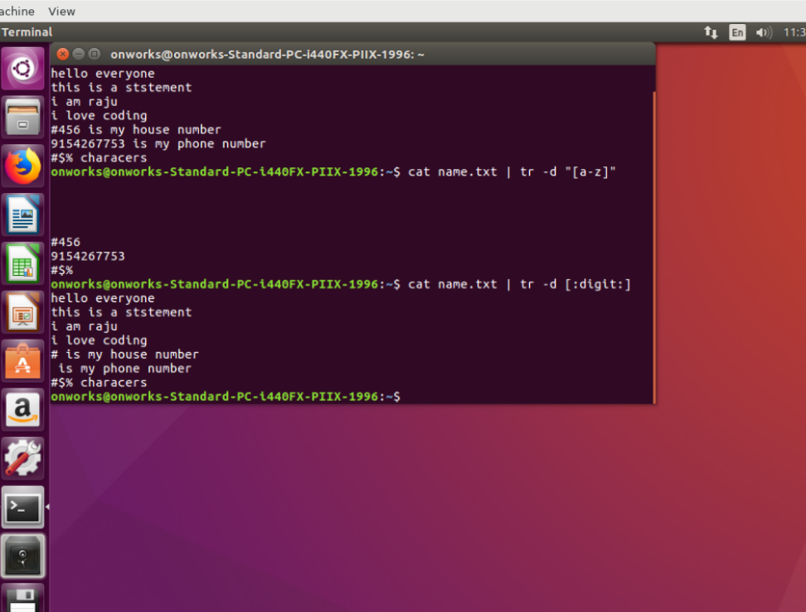

**9. $echo “this is a string” | tr ‘ia’ ‘96’**: This will replace the ia by 96.

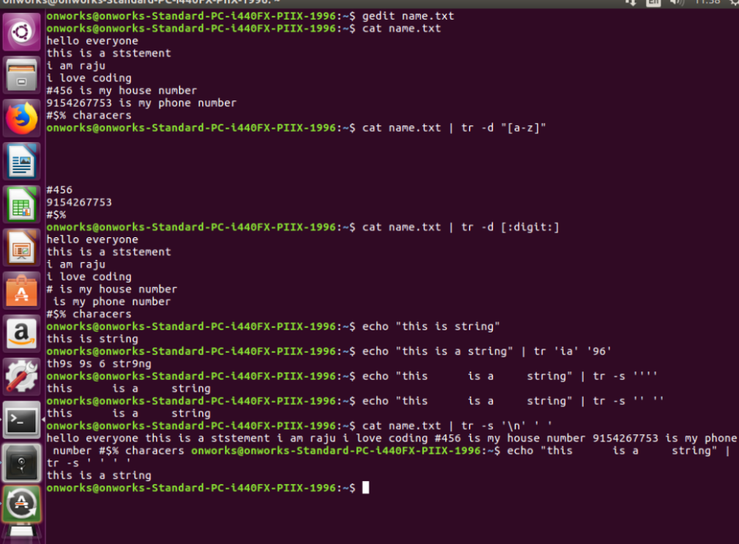

**10. $tree:** shows the hierarchical structure of the files.

